**Laboratory 3: Models of Homogeneous Populations**

**BSEN 5250/6250**

**What to Turn In:** The spreadsheet template for this Lab is located in Canvas in \Files\Labs\Lab3\Lab 3-Homogeneous Populations.xlsx. For each problem, answer the questions and cut and paste your graphs from Excel into your write-up. Format your graphs according to professional journal standards. Label the each axis. Remember that model results should be shown as lines with no points and data should be shown as points. Give each figure a number and refer to the figure number in your discussion. Upload your word document and spreadsheet to Canvas.

**Problem 1.** The following data for yeast biomass were collected over time. Use the Euler method to solve the Verhulst-Pearl equation using a timestep of 1 hour. You can use Excel rather than VBA for this exercise. Use Excel Solver to estimate the coefficients for τ and K that minimize the cumulative percent error between simulated and observed yield. ***What to turn in:*** Briefly describe what you did and show a graph of the best fit of simulated and measured values.

Verhulst-Pearl Equation is $\frac{dN}{dt}= τ N \left(1- \frac{N}{K}\right)$

Where N = yeast cell population, mg/100 mL

K = carrying capacity, mg/100 mL

τ = growth rate, 1/hour

t = time, hours

There are many Youtube videos that can teach you how to load Solver as an add-in within Excel. An example can be found at <https://www.youtube.com/watch?v=K4QkLA3sT1o> .

The percent error (PE) between simulated and measured data can be computed for each value of time that contains a measured value and simulated value by PE = |Simulated – Measured|/Measured * 100

The cumulative percent error can be computed by summing up the PE for each data point.

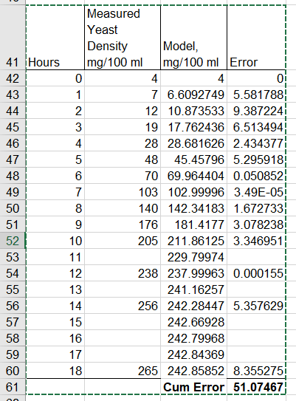

**Problem 2.** Time Lags with Oscillations. This is exercise 7-3 in Chapter 7 of your textbook. Write an Excel spreadsheet (do not use VBA) to simulate population growth in which there is a time lag (f) in resource use, based on Equation 7.4 in your text (see class notes for variable definitions). N is the population level, k is carrying capacity and Ƭ is the growth rate of the population at a minimum density. The variable f is the time lag.





Set carrying capacity k=1000, Initial population No = 2 and growth rate at minimum density τ = 0.5. Allow your simulation to proceed for about 50 days, plotting Nt against time. Use a time step of dt=1 day. Develop graphs for different time lags f=0, 1, 2, 3, and 4. ***What to turn in:*** Briefly describe what you did and discuss the meaning of the graphs. Why do the graphs change for different values of f?

To solve this problem, you need to make assumptions about the initial values of N prior to time t=0. Assume that values for Nt=-4, Nt=-3, Nt=-2, Nt=-1 = 0.

You can use the “Offset” command in Excel to allow the cell references used to compute Nt-f for different values of f to change automatically for different values of f. If you want to refer to a cell, say C5 in an equation, and rather than using C5 you would like to use C5 ± rows ± columns, you can use the following syntax in your cell equation:

Y = A1 + B1 * **OFFSET**(C5,***rows,columns***)

The reference to cell C5 is now offset by the number of rows and columns that you set. The values for rows and columns can be entered as numbers or other cell reference. You may find this helpful when you begin to vary the value of f from 0 to 4.

**Problem 3.** This problem is discussed in section 7-3 in your textbook. Develop a spreadsheet to solve the Logistics equation with variable carrying capacity shown below (do not use VBA). Assume that the carrying capacity, K, changes annually in a sawtooth pattern as shown in class. Set C=30 individuals, N0 = 2 individuals, g = 0.3 per week and k = 6 individuals per week. Run the spreadsheet model for 104 weeks using a timestep of dt=1 week. **What to turn in:** Show a graph of the carrying capacity (K) and the population (N) vs time. Describe the behavior of the system.







**Where:**

Nt = number at time t C = minimum carrying capacity

Kt = number k = slope of change in carrying capacity

t = time τ = time constraint on carrying capacity

dt = time step τ = t for 0 ≤ t ≤ 26 weeks

g = 1/time τ = 52 - t for 26 ≤ t ≤ 52 weeks

Note that you are solving this problem over two annual cycles (104 weeks). Thus, the value for Ƭ needs to be able to handle the year change at 52 weeks and restart the pattern.